**Requirements for suppliers regarding weight, size and type of packaging in which raw materials and other goods are delivered to Pratt & Whitney Tubes**

In the case of deliveries of goods from countries other than EU Member States or Switzerland, it must be ensured that the deliveries are not made in wooden packaging (such as pallets, dunnage, crates, crates, drums, boxes, loading platforms, stands, etc.) , **unless they meet the ISPM15** (*International Standards For Phytosanitary Measures No. 15*) standards set by the IPPC (*International Plant Protection Convention*) and are marked with the mark shown below, which is intended to certify that the raw wood packaging so marked has been subjected to an approved fumigation treatment.

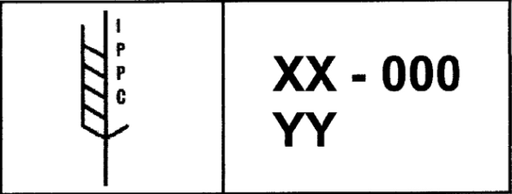

***IPPC*** *– International Plant Protection Convention*

***XX*** *–ISO country code / e.g. PL – Poland*

***000*** *– packaging manufacturer number*

***YY*** *– type of approved treatment / e.g. HT – Heat Treatment*

Wooden packaging made entirely of wood-based materials, such as plywood, particle board, oriented strand board or veneer board made using glue, heat and pressure, should be considered to have been sufficiently processed to eliminate the risks associated with raw wood.

In order to ensure highest possible work safety standards as well as to minimise ergonomics-related risks and hazards, the following requirements concerning parameters of raw materials/goods and packaging in which they are delivered to PWT are hereby specified.

1. **Requirements for bars, blanks and their packing methods**

* Bars delivered to PWT must not be longer than **1 m** (**3,4 ft**) and heavier than **23 kg** (**50 lbs**).
* All sharp edges must be blunted (deburred).
* Bars must be delivered on **pallets or in box pallets** whose size conforms to the EUR standard (euro-pallet, half-pallet), in sound technical condition (no cracks, holes, etc.) and designed for side loading/unloading, i.e. with an additional reinforcing element along their width.
* Blanks must be delivered in **box pallets** whose size conforms to the EUR standard (euro-pallet, half-pallet), in sound technical condition (no cracks, holes, etc.) and designed for side loading/unloading, i.e. with an additional reinforcing element along their width.
* The maximum material weight must not exceed **500 kg**.

**Example:**

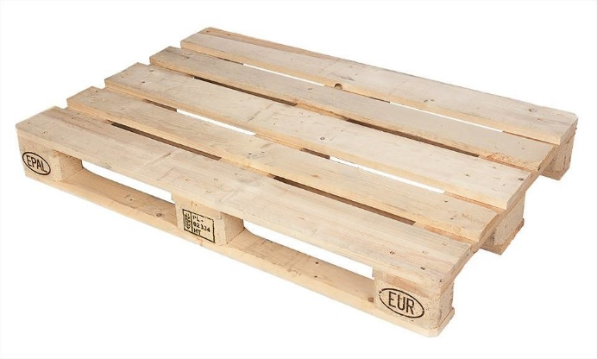

1. **Requirements for pipes and their packing methods**

* Pipes must be delivered to PWT with their sharp edges resulting from cutting operations deburred (blunted).
* Pipes can be delivered to PWT in wooden crates with **specified load capacity and rigid structure.**
* The maximum crate length is **3,2 m.**
* The crate length should be adjusted to the material length.
* Pipe crates must be designed in a manner facilitating safe loading/unloading with a standard (pallet) lift truck.
* The maximum material weight must not exceed **250 kg**.

**Example:**

